**ASSIGNMENT 2**

**AIM:-**

Design at least 10 SQL queries for suitable database application using SQL DML

statements: Insert, Select, Update, Delete with operators, functions, Set operators,

Clauses.

**OBJECTIVE:-**

To implement DML Operations.

**OUTPUT:-**

**CREATE TABLE SALE5 AND SALE6**

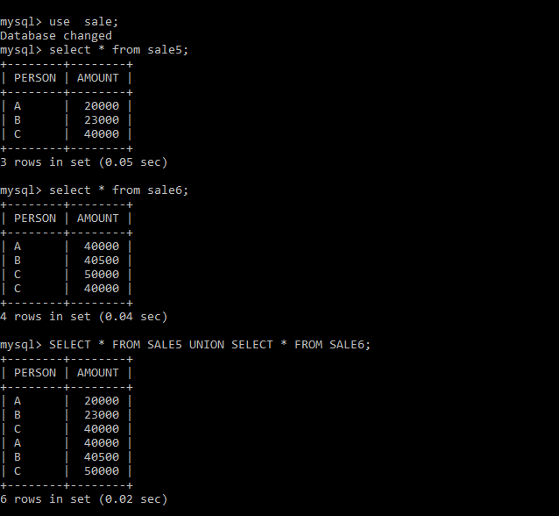

**UNION AND UNION ALL**

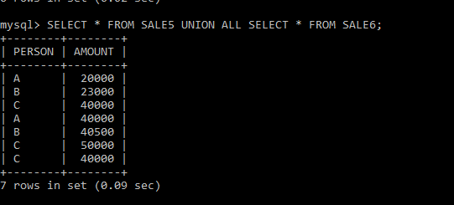

**DELETE**

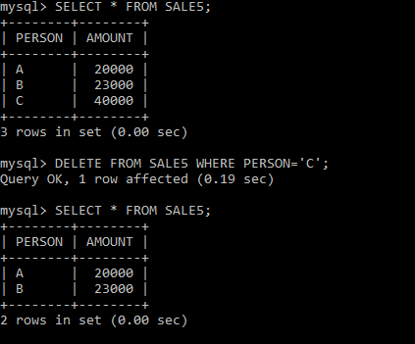

**UPDATE OPERATION**

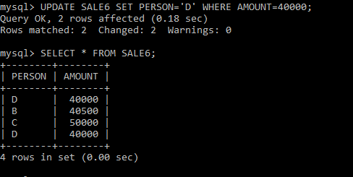

**CREATE TABLE EMPLOYEE AND COUNT AND MAX SALARY**

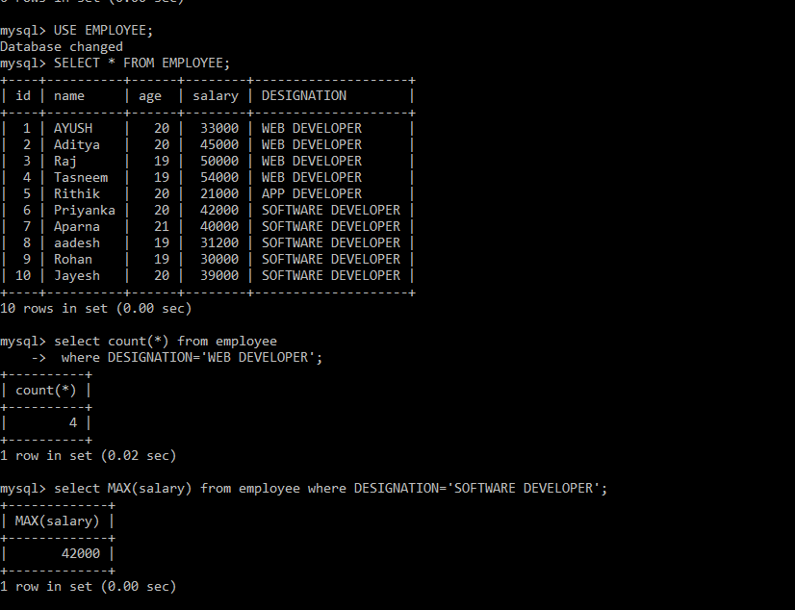

**HAVING BY AND GROUP BY:-**

